

**ASSIGNMENT COVER**

(Be sure to keep a copy of all work submitted)

FLKT/06-00

**To be completed by student – Please Print Clearly**

|  |  |  |
| --- | --- | --- |
| Name(s):   1. Muhammad Khairul Anwar bin Mohamad Hashim 2. Mohamad Nor Aizudin bin Khairil Anuar 3. Muhammad Zulhilmi bin Shah Eran 4. Nurul Nadia binti Mohd Nazri | | |
| ID Number(s):   1. AM1801003439 2. AM1801003505 3. AM1801003510 4. AM1709003138 | | |
| Lecturer Name:  Sir Mohamed Ghazali bin Khairuzzaman | | Lab group / Tutorial group / Tutor (if applicable):  Section 1 |
| Course Name and Course Code:  Information Security Assurance (NET405) | | Submission Date:  6 MAY 2019 |
| Assignment No. / Title Proposal:  Dating Website (Chatty Chatty) | | Extension & Late Submission:  * Allowed / Disallowed |
| Assignment Type:  Group | % of Assignment Mark: | Returning Date: |
| **Penalties:**   1. 10% of the original mark will be deducted for every one-week period after the submission date 2. No work will be accepted after two week of the deadline 3. If you were unable to submit the coursework on time due to extenuating circumstances, you may be eligible for an extension 4. Extension will not exceed one week | | |
| Declaration: I/We the undersigned confirm that I/we have read and agree to abide by these regulations on plagiarism and cheating. I/we confirm that this of work is my/our own. I/we consent to appropriate storage of our work for checking ton ensure that there is no plagiarism/academic cheating.  Signature(s): ..……………….. …………………… ……………………. ……………………..  Full Name: (Khairul) (Aizudin) (Zulhilmi) (Nadia) | | |
| This section may be used for feedback or other information | | |
|  | | |

**1.0 Introduction**

Chatty Chatty dating websites is about looking for life partner. The term 'dating' refers to a process through which a person gets together with another person to explore the possibilities of romantic coupling. People generally start dating in their middle teen years sometime after puberty has started. The majority of people at first date in searching fashion, forming intense but temporary unions with one or more people in series. Chatty Chatty dating websites exploration dating tends to turn into more goal-directed dating as people age into adulthood and experience social and internal pressures to 'get married', settle down and have a family. Though most adults do end up forming more permanent committed relationships, not all who do remain faithful to their relationships. Some substantial minority of married adults continue to date after marriage by forming adulterous liaisons and affairs. While many committed relationships do thrive, a number also fail due to divorce, death and other circumstances. The survivors of these relationships, bruised as they are, often find themselves motivated to go back into the dating pool to try their luck at relationship building again.

**2.0 BPMN Modelling**

Business Process Modelling Notation (BPMN) is a flow chart method that models the steps of a planned business process from end to end. A key to Business Process Management, it visually depicts a detailed sequence of business activities and information flows needed to complete a process. Its purpose is to model ways to improve efficiency, account for new circumstances or gain competitive advantage. The method has been undergoing a standardization push in the past few years and is now often called by a slightly different name: Business Process Model and Notation, still using the BPMN acronym. It differs from Unified Modelling Language (UML) used in software design. This chapter we will briefly explain on how each Pool or Level works on or Business Process Modelling notation Diagram.

**2.1 Register**

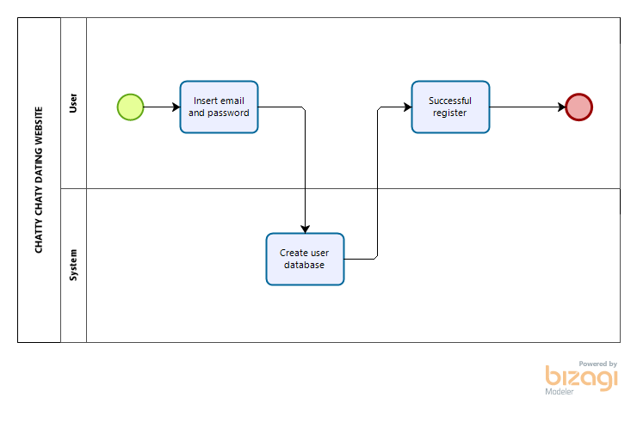

The first lane is User. This section is used by the user to register at Chatty Chatty dating website and user need to register their account on our website. User need to enter their email and password. For the second lane, user account will be creating in our website database. After succeed, user will get successful register notification.

**2.2 Login**

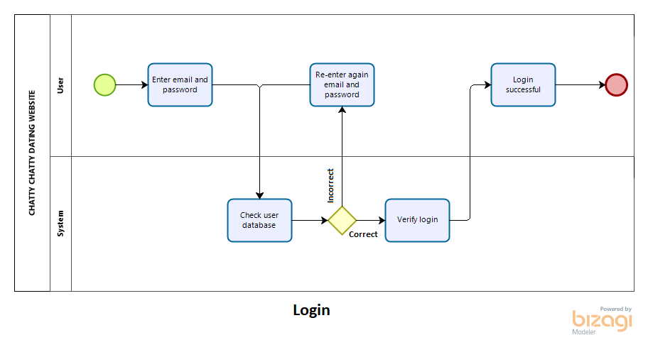

The first lane is User. This section are used by the user to login at Chatty Chatty dating website and users need to login their account on our website. User need to enter their email and password. For the second lane, user account will be check in our website database. If user put wrong email or password, user need to re-enter again email and password. After check, system will verify login. After succeed, user will get login successful notification and login in our website.

**2.3 Search**

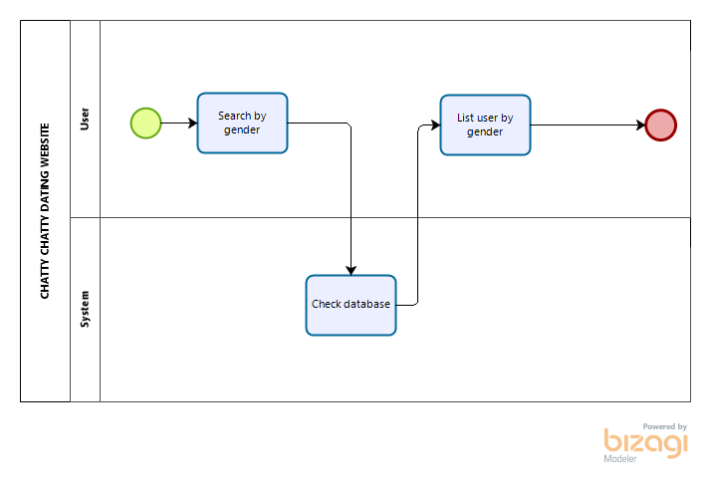

The first lane is User. This section is used by the user to search at Chatty Chatty dating website and users can search for other user account on our website. User need to search by gender. For the second lane, system will be check user search in our website database. After succeed, user will get list user by gender.

**2.4 Chatting**

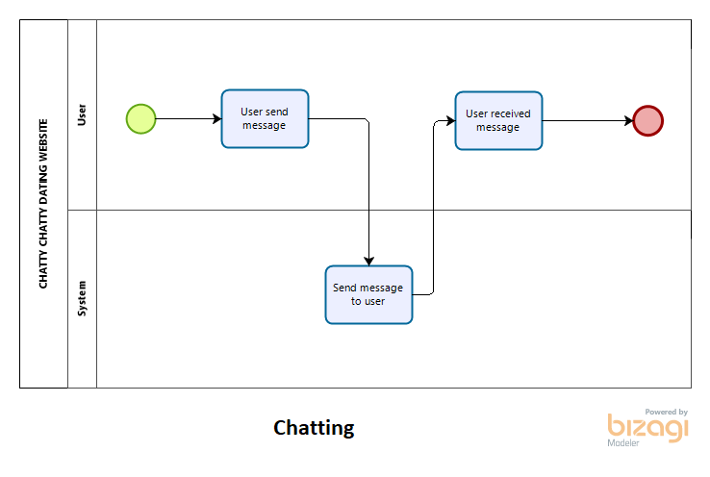

The first lane is User. This section is used by the user to chat at Chatty Chatty dating website and users can chat with other user account on our website. User will get limited chat and user can send message to other user. For the second lane, system will send message to other user in our website database. After succeed, user will receive message.

**2.5 VIP user**

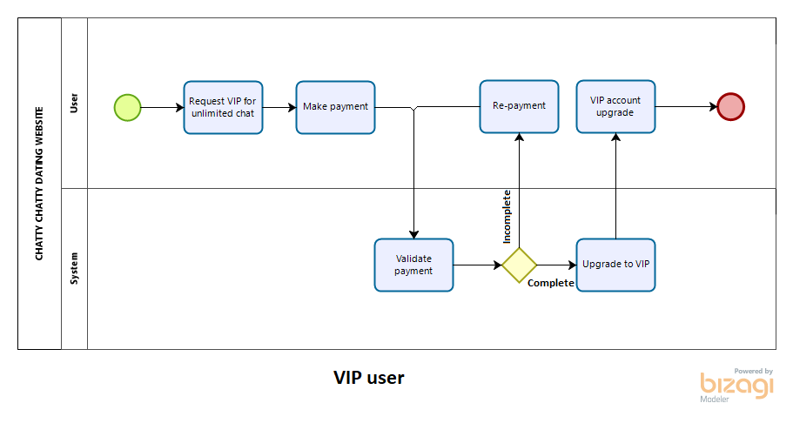

The first lane is User. This section is used by the user to upgrade VIP at Chatty Chatty dating website and users can request VIP on our website. User reach limited chat and user can request VIP. After that, user need to make payment on our website. For the second lane, system will validate payment by user. If payment not complete, user need to remake payment again. System will upgrade user to VIP. After succeed, user will get VIP notification.

**3.0 Work Breakdown Structure**

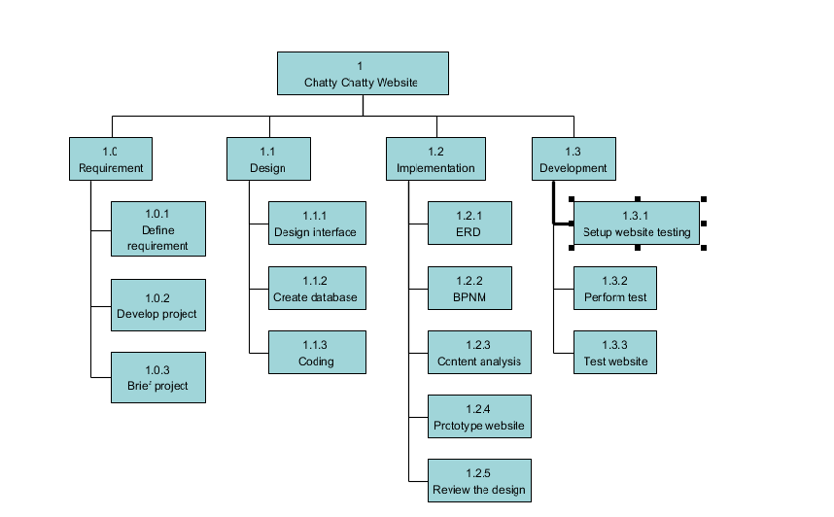

For work breakdown structure, Chatty Chatty dating websites include 4 main process to finished up the websites. The process is divided into 4 which is requirement, design, implementation and development. In requirement we provided 3 sub main which is:

**3.1 Requirement**

**3.1.1 Define requirement**

We define the requirement for list of necessary functions, capabilities, or characteristics for our dating website and the plans for creating it.  There are several types of requirements that may be defined during the process that come together to focus and prioritize the project plan. First is user requirement which is how user expectations and how they will interact with the product.  Use the features, functions, and content described in your scenarios to develop your requirements.

**3.1.2 Develop project**

Secondly, we develop the project. Web sites are good for many purposes. They can be as simple as an online brochure for your business or an online resume, which allows prospective employers to view your portfolio. The first step you have to take when building a web site is to determine the purpose of your site. In time, this purpose will help you develop a mission statement for the site, which will help keep your project on task and focused.

**3.1.3 Brief project**

Lastly, brief the project which is that allows you to identify the scope, scale, and core details for our upcoming design project. Populated with the right information, the design brief has the potential to be one of your most powerful tools. It can be used to inform design decisions and effectively guide the overall workflow of your project; from conception to completion. In design we provided 3 sub main which is firstly is:

**3.2 Design**

**3.2.1 Design interface**

User interface design (UI) or user interface engineering is the [design](https://en.wikipedia.org/wiki/Design) of [user interfaces](https://en.wikipedia.org/wiki/User_interface) for [machines](https://en.wikipedia.org/wiki/Machine) and [software](https://en.wikipedia.org/wiki/Software), such as [computers](https://en.wikipedia.org/wiki/Computer), [home appliances](https://en.wikipedia.org/wiki/Home_appliance), [mobile devices](https://en.wikipedia.org/wiki/Mobile_device), and other [electronic devices](https://en.wikipedia.org/wiki/Electronics), with the focus on maximizing [usability](https://en.wikipedia.org/wiki/Usability) and the [user experience](https://en.wikipedia.org/wiki/User_experience). The goal of user interface design is to make the user's interaction as simple and efficient as possible, in terms of accomplishing user goals.

Good user interface design facilitates finishing the task at hand without drawing unnecessary attention to itself. [Graphic design](https://en.wikipedia.org/wiki/Graphic_design) and [typography](https://en.wikipedia.org/wiki/Typography) are utilized to support its [usability](https://en.wikipedia.org/wiki/Usability), influencing how the user performs certain interactions and improving the aesthetic appeal of the design; design aesthetics may enhance or detract from the ability of users to use the functions of the interface.

Interface design is involved in a wide range of projects from computer systems, to cars, to commercial planes; all of these projects involve much of the same basic human interactions yet also require some unique skills and knowledge. As a result, designers tend to specialize in certain types of projects and have skills cantered on their expertise, whether that be [software design](https://en.wikipedia.org/wiki/Software_design), user research, [web design](https://en.wikipedia.org/wiki/Web_design), or [industrial design](https://en.wikipedia.org/wiki/Industrial_design).

**3.2.2 Create Database**

While using an [online database](https://zenkit.com/en/blog/everything-you-need-to-know-about-web-databases/) service provider does cut out the need for coding expertise, there are some platforms that may require you to have a bit of basic programming knowledge — most commonly languages such as [HTML](https://en.wikipedia.org/wiki/HTML), [JavaScript](https://en.wikipedia.org/wiki/JavaScript), and [CSS](https://en.wikipedia.org/wiki/Cascading_Style_Sheets). However, for those without any prior knowledge, if you Google ‘online database builders’, you’ll come across platforms that won’t require it. The process of creating an online database is essentially setting up a server account, and using software tools to create the database and its structures. Here are the things you’ll need to start building.

**3.2.3 Coding**

Web programming refers to the writing, mark-up and coding involved in Web development, which includes Web content, Web client and server scripting and network security. The most common languages used for Web programming are XML, HTML, JavaScript, Perl 5 and PHP. Web programming is different from just programming, which requires interdisciplinary knowledge on the application area, client and server scripting, and database technology.

In implementation we provided 5 sub main which is firstly is:

**3.3 Implementation**

**3.3.1 Entity Relationship Diagram**

An entity relationship diagram (ERD) shows the relationships of entity sets stored in a database. An entity in this context is an object, a component of data. An entity set is a collection of similar entities. These entities can have attributes that define its properties. By defining the entities, their attributes, and showing the relationships between them, an ER diagram illustrates the logical structure of databases. ER diagrams are used to sketch out the design of a database.

**ERD for Chatty Chatty**

An entity relationship diagram (ERD) shows the relationships of entity sets stored in a database. An entity in this context is an object, a component of data. An entity set is a collection of similar entities. These entities can have attributes that define its properties. By defining the entities, their attributes, and showing the relationships between them, an ER diagram illustrates the logical structure of databases. ER diagrams are used to sketch out the design of a database.

**ERD for Chatty Chatty**

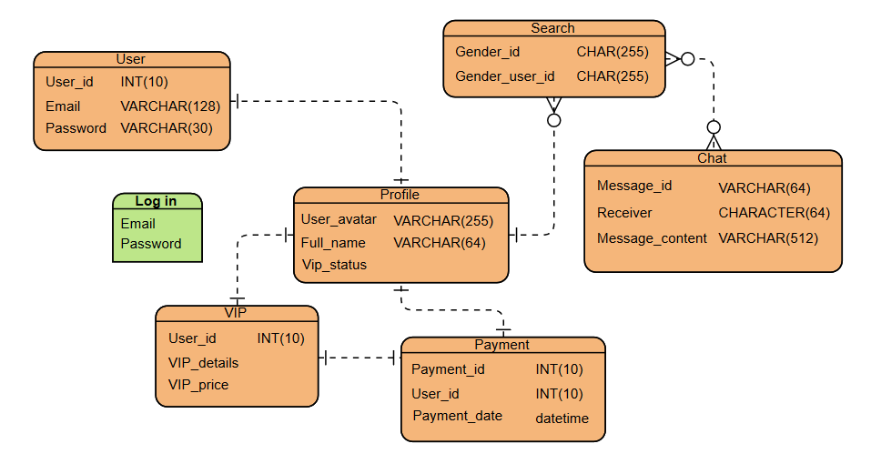

Start from sign up, new user can sign up using their email. All the attributes are required to fill in. Then, the user is successfully registered and officially become Chatty Chatty users. For user that already registered, they only need to sign in using their email and password. Users can edit their profile or account such as enter their full name and upload their pictures for easily get match from others user. Other than that, user can search people to chat. If the user is male, it automatically searching for female user and if the user female, they will find male user. However, the chat is limited for free user. They need to subscribed for VIP account for the unlimited chat in period of time depends on their subscription. We as the developer of Chatty Chatty, we hope users can found their spouse.

**3.3.2 BPNM**

Business Process Modelling Notation (BPMN) is a flow chart method that models the steps of a planned business process from end to end. A key to Business Process Management, it visually depicts a detailed sequence of business activities and information flows needed to complete a process. Its purpose is to model ways to improve efficiency, account for new circumstances or gain competitive advantage. The method has been undergoing a standardization push in the past few years and is now often called by a slightly different name: Business Process Model and Notation, still using the BPMN acronym. It differs from Unified Modelling Language (UML) used in software design. This chapter we will briefly explain on how each Pool or Level works on or Business Process Modelling Notation Diagram.

**3.3.3 Content Analysis**

The method is an adaptation of content analysis techniques that have been used to code and interpret political campaign advertising on television and radio for the Web environment. The units of analysis are the official party and candidate websites – which are sub-divided into three main types: 1) home pages 2) social media or web 2.0 platforms (Twitter and Facebook profiles, YouTube channels) and 3) the new Activist Centres.

Coding schemes specific to each type of site are designed that capture the design and purpose of the sites by registering the presence or absence of a series of web-specific ‘features’ or items – such as manifesto pdfs, online donation, email contacts and chatrooms, These individual items are cumulated into ‘functional’ indices that measure the sites’ performance of a range of campaign activities, including message dissemination, promoting participation, volunteer recruitment and activism and resource generation.

**3.3.4 Prototype websites**

Website prototypes are interactive demos of a website. These are often used to gather feedback from project stakeholders early in the project lifecycle, before the project goes into final development. A website prototype can be any mock-up or demo of what a website will look like when it goes live. It can be anything from a paper sketch, to a clickable HTML prototype. However, typically when people talk about a prototype they are referring to an interactive prototype of some kind which allows users to navigate from page to page and use functionality such as drop down menus.

There are a variety of different ways to create an interactive prototype. We’ve seen clickable prototypes in PowerPoint, PDF documents and even MS Word. But there are a variety of specialist prototyping tools available on the market that are specifically designed to make prototyping easy. Check out [Blasamiq](http://www.balsamiq.com/), [Axure](http://www.axure.com/) and [Mockingbird](http://gomockingbird.com/) for just a few examples.

**3.3.5 Review the website**

Reviewing websites is simple enough. Just go to a website, browse through the pages and form an opinion about what the website offers. Good or bad, the review should focus on what is important to the audience. The audience is made up of potential users of the website. Let people know why the website is worth visiting, or why it's not. In development we provided 3 sub main which is firstly is:

**3.4 Development**

**3.4.1 Setup websites testing**

A review website is a simple website which provides reviews of products, goods, and services which are majorly used by the masses. The list of products and services is ever increasing. Every other day, we have a new gadget, mobile or an app launched which you can review and write your views on your review website. The biggest advantage of a review website- it has a very good potential to generate passive income.

**3.4.2 Perform test**

We all have to agree that in today’s ever-changing and competitive world, the internet has become an integral part of our lives. Most of us make our decisions by searching the information on the internet these days, hence hosting a website is no longer optional but mandatory for all kind of businesses. It is the first step in becoming and staying relevant in the market. Just having a website is not enough. An organization is needed to develop a website that is informative, accessible and user-friendly. To maintain all these qualities, the website should be well tested, and this process of testing a website is known as web testing.

**3.4.3 Test websites**

Web testing is the name given to [software testing](https://en.wikipedia.org/wiki/Software_testing) that focuses on [web applications](https://en.wikipedia.org/wiki/Web_application). Complete testing of a web-based system before going live can help address issues before the system is revealed to the public. Issues may include the security of the web application, the basic functionality of the site, its accessibility to handicapped users and fully able users, its ability to adapt to the multitude of desktops, devices, and operating systems, as well as readiness for expected traffic and number of users and the ability to survive a massive spike in user traffic, both of which are related to [load testing](https://en.wikipedia.org/wiki/Load_testing).